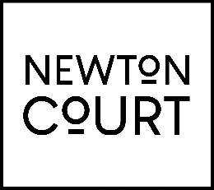
Job description and person specification

Job title: Front of House Assistant
Location: Newton Court
Hourly Rate: £10.42 per hour (increasing to £11.44 in April 24)
Hours: Daytime hours Monday to Sunday with occasional evenings
Reports to: Front of House Manager

Job purpose:
To provide excellent customer service to all visitors to Newton Court whilst undertaking a range of front of house activities

Responsibility areas

Front of House
- Undertake a range of front house activities such as
  - clearing and relaying tables
  - taking orders and payment
  - delivering food and drink orders
  - preparing drinks and making coffee
  - polishing cutlery
  - Filling salt and pepper pots
- To listen to and where possible resolve any customer concerns, noting any issues and escalating to Front of House Manager, Assistant Manager, or Head Chef as necessary
- To carry out start and end of shift duties e.g.
  - Clean and lay all tables
  - Clean the bar area, trays etc

Person Specification

Teamworking
Fits in with the team. Develops effective and supportive relationships with colleagues. Is considerate towards them and creates a sense of team spirit.

Specialist knowledge and experience
Experience of providing a hospitality service to the general public

Customer Focus
Quickly builds rapport and easily establishes relationships with customers. Relates well to different types of customer, listens and gets on with them. Puts the customer first and is eager to please them. Works hard to meet customer needs and looks after their
interests.

Communication
Speaks confidently and fluently. Talks at a suitable pace and level. Holds others’ attention when speaking.

Reliability
Is reliable; follows directions from supervisors and respects policies and procedures. Shows commitment to the organisation and task completion.

Resilient
Remains calm and self-controlled under pressure. Reacts well to change and stays positive despite setbacks. Keeps difficulties in perspective.

Special conditions
- Hours are on a rota basis over seven days a week, during restaurant opening hours. Individual preferences are accommodated where possible however cannot always be guaranteed.
- Uniform is provided by way of a Newton Court T-Shirt and Apron.

Updated February 2024

